CURRICULUM VITAE

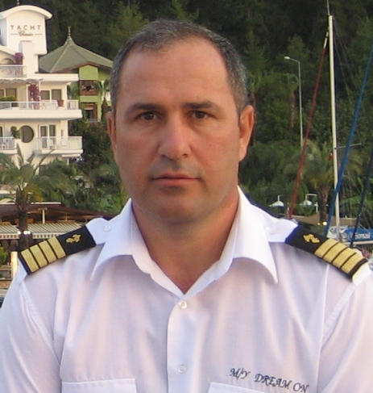
Name ,Surname : K.Tamer ERTAN
Natıonalıty : Turkish
Date of Birth : 15.09.1964
Sex : Male
Marıtal Status : Married
Languages : English
Contact : Ataturk cad. Kelebek Vadisi evleri A-2.Blok D.9
Yayalar -PENDİK/İSTANBUL
Tel : Home-(216)3079559-GSM-(532)2879610

EDUCATION
1975-1978 : Primary School
1978-1981 : High School
  - : İ.T.Ü. Maritime Faculty (Course for Captain)

QUALIFICATIONS
License : MASTER
ON SHIP LESS THAN 3000 GT IN ALL WATERS
(Ocean Going) Master Unlimited. (MCA convertible)
CERTIFICA OF ENDORSEMENT SINGAPORE ( MPA )

Certificates Personal Survival Course Certificate
Basic Fire Fighting Course Certificate
First Aid At Sea Course Certificate
Proficency Survival Craft Course Certificate
Advanced Fire Fighting Certificate
Medical Care Aboard Ship Certificate
Medical First Aid Certificate
Personal Safety And Social Renponsibility Certifcate
Radar Observation And Plotting Course Certificate
The Operational Use Of Automatic Radar Plotting
AIDS (Arpa) Course Certificate
VHF Radio Communications Certificate
General Operators Certificate ( GOC / CMDSS )
BRİDGE Team Management Course Certificate
ECDİS Course Certificate
Brevet International ( CMAS )
Hobbies Sport (running,football...vb) Diving,Reading.sailling

WORK EXPERİENCE
November 1983-December 1985 Karavelioğlu Denizcilik (M/T GOKSU) 110 m
May 1986-April 1987 Turkish Naval Forces ( TCG ANITTEPE )
May 1989-November 1990 Shipping Company (M/V AHORA )
November 1991-January 1993 Das Vapur Dnz (M/T YUSUF REİS ) 50 m
January 1993-March 1998 M/Y SAVARONA (World’s Largest Private Yacht)
May 1998-September 2001 AKSAY Shipping Company (LNG/T YASEMİN S ) 90m (F.O)
September 2001 – September 2005 M/Y ANATOLİA 47 m ( F.O )(mediterranean,ionian sea,Adriatic sea.
September 2005- October 2006 Captain of M/Y ANATOLİA (Greek and Turkey cost.
January 2007- 2013 Captain of M/Y DREAM ON (38 M) (Shipyard-mediterranean and Frenc riviera……)
2008-October Genova-Tuzla Captain of M/Y DejaToo 52 m (Deliver)

